

COLLEGE OF ELECTRICAL AND MECHANICAL ENGINEERING

DEPARTMENT OF SOFTWARE ENGINEERING

Internet Programming II

Section C

Mysteria Restaurant Website

Instructor’s name: Mr. Chere Lemma

**TEAM MEMBERS** **ID**

1. Tsedey Mekonnen ETS1050/12
2. Meron Abera ETS0451/12
3. Meron Edea ETS0450/12
4. Okitta Ongaye ETS0555/12
5. Rediet Berhane ETS0563/12
6. Paulos Teshome ETS0556/12

***2022 G.C***

# About the Project

This project proposes an online restaurant website that helps communication between all teams within a restaurant by minimizing the probability of human errors, providing an online table and event reservation, food ordering including delivery as an option.

# How to install and run the website

**Step 1:** Download the Document in a zip file and unzip it in a xampp server htdocs folder.

**Step 2:** Download the mysteriadb.sql database and import it in the phpmyadmin in the xampp server.

**Step 3:** Run the website in any browser using your localhost (i.e. localhost/Mysteria).

# How to use the website

**Step 1:** You need to register to the website using this form.

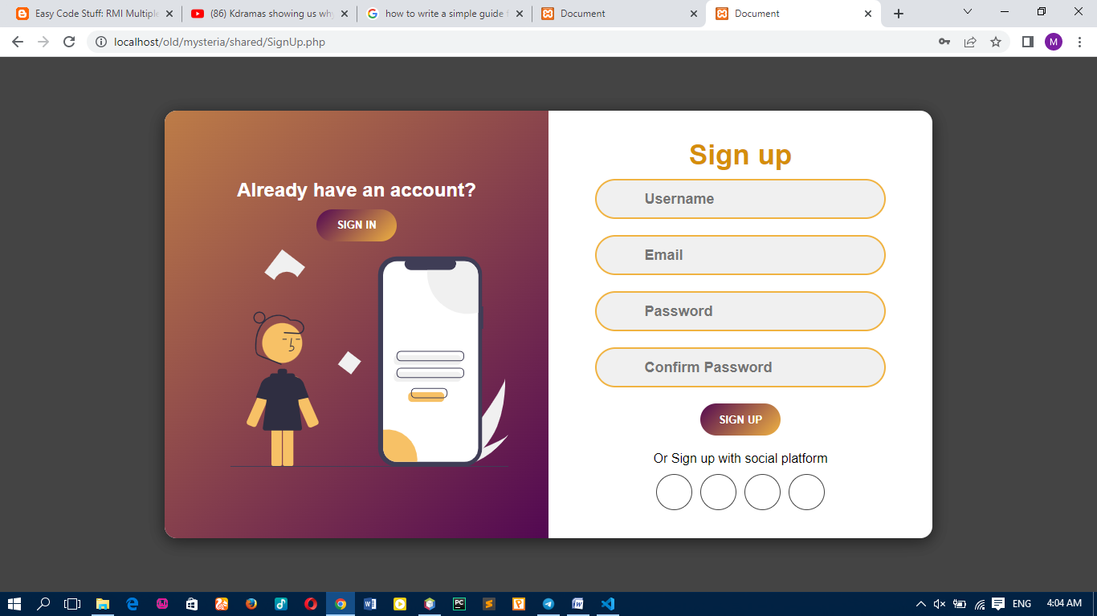

**Step 2:** You need to login using the username and password you used while registering.

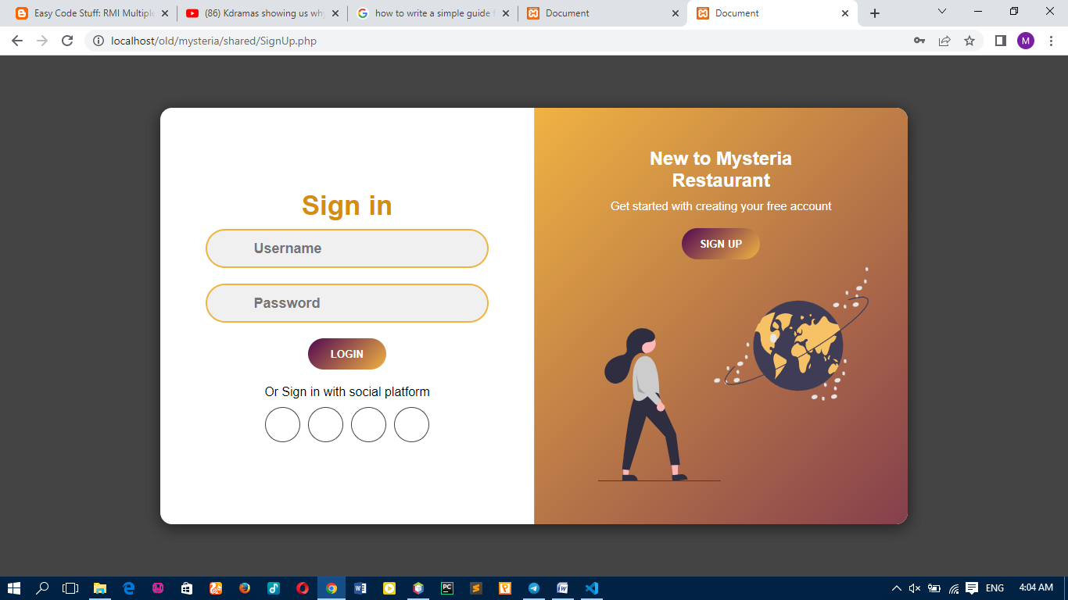

Step 3: If you log in successfully, since you are a customer it will take you to user home page that looks like this.

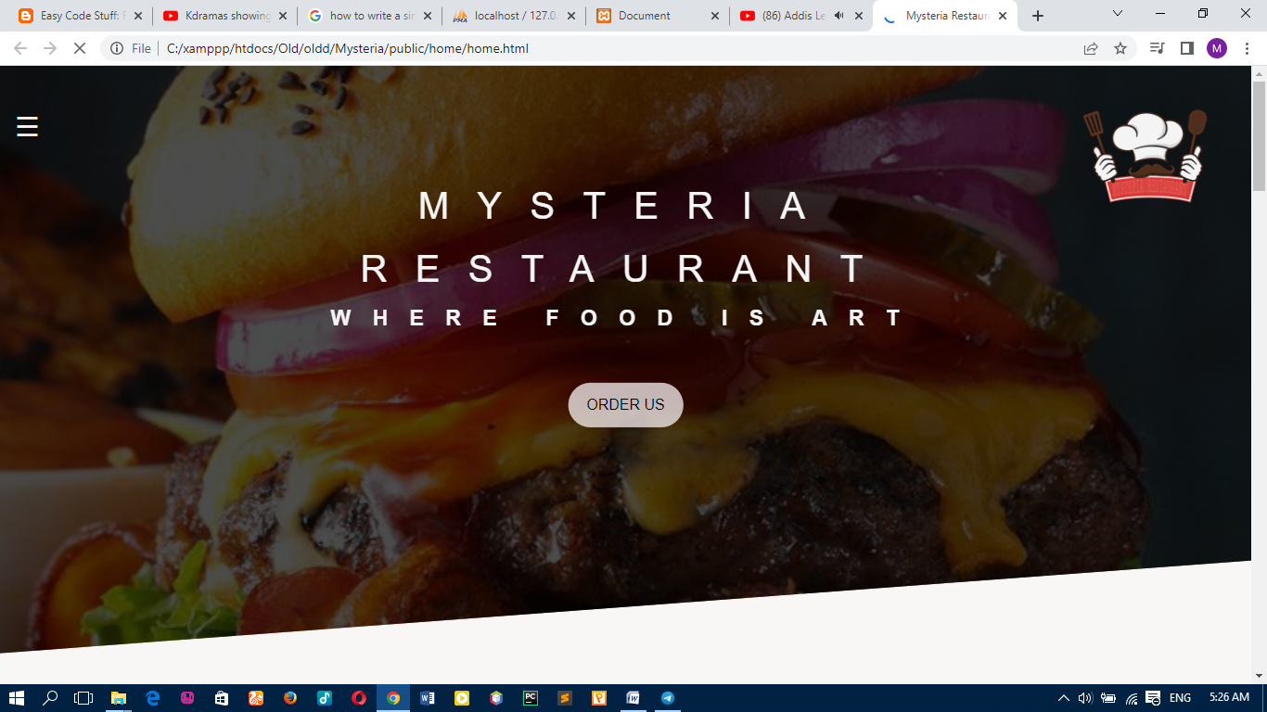

You can navigate through the website services through the navigation bar on the left.

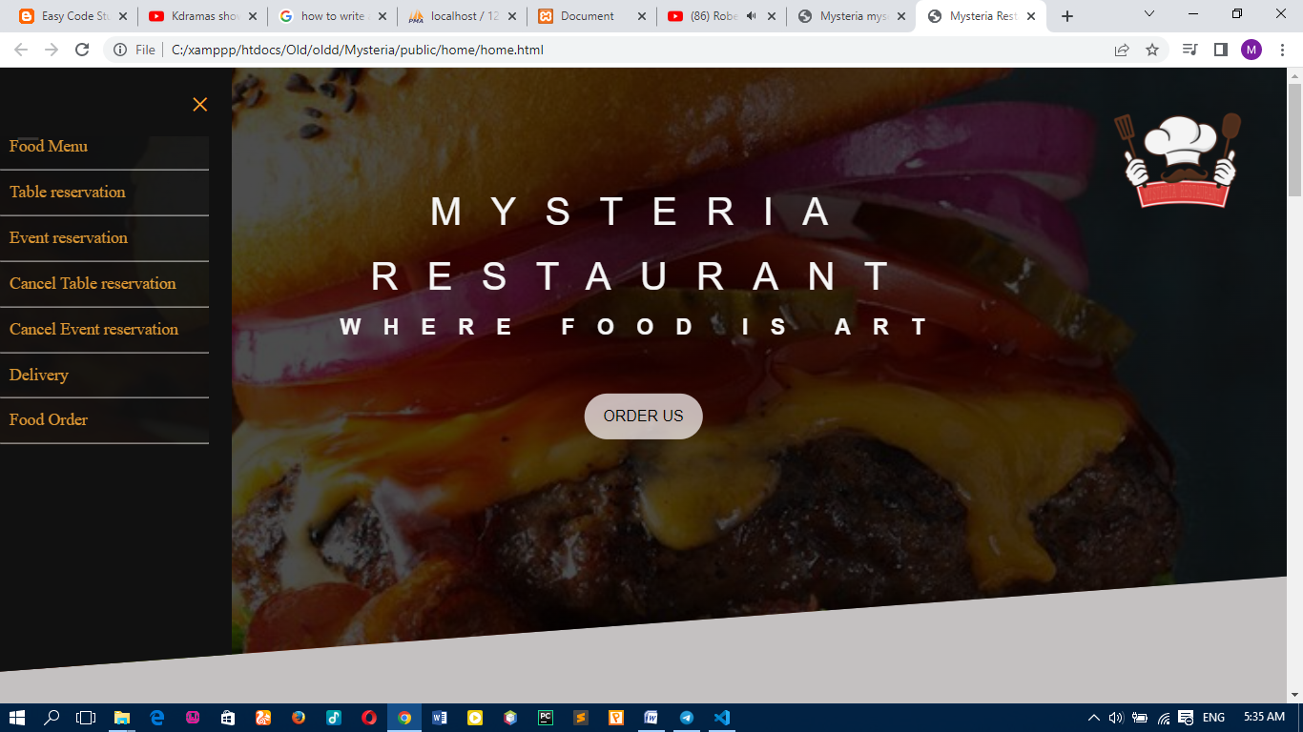

You can look at the food menu and order anything you want.

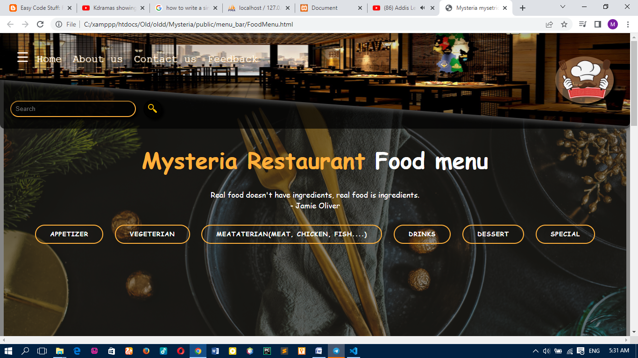

You can reserve a table by filling the table reservation form.

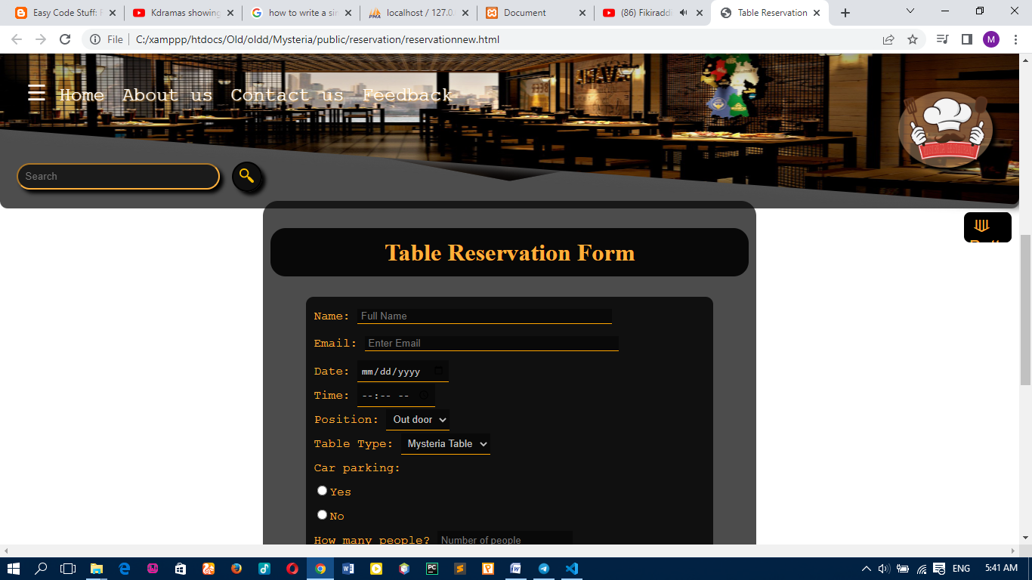

You can use the event reservation form to reserve for any event in the options.

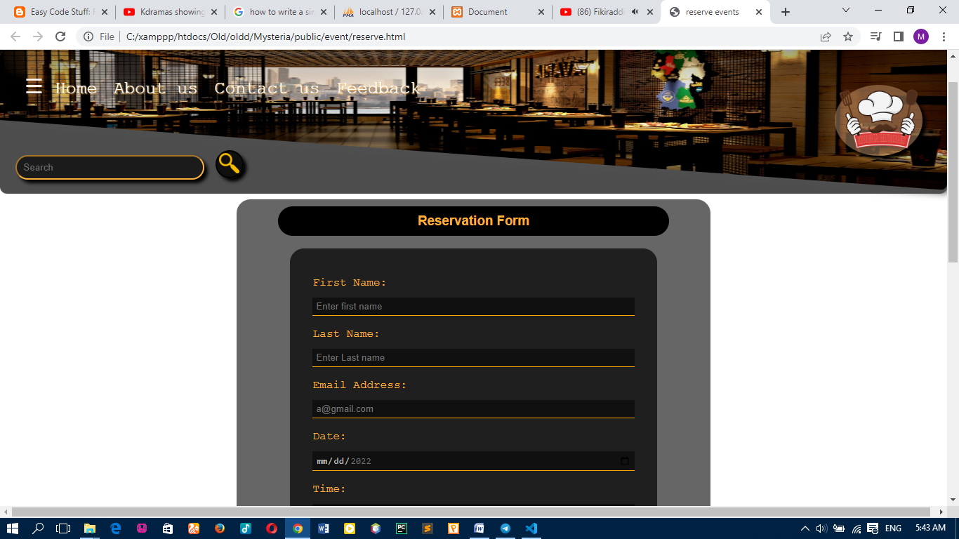

You can use the delivery form and order form to order food and drinks.